LAB REPORT 09
Simscape Electrical Circuit Simulations
Example 01: Simple DC Circuit Simulation
Find voltages V1 and V2 in the simple DC circuit.

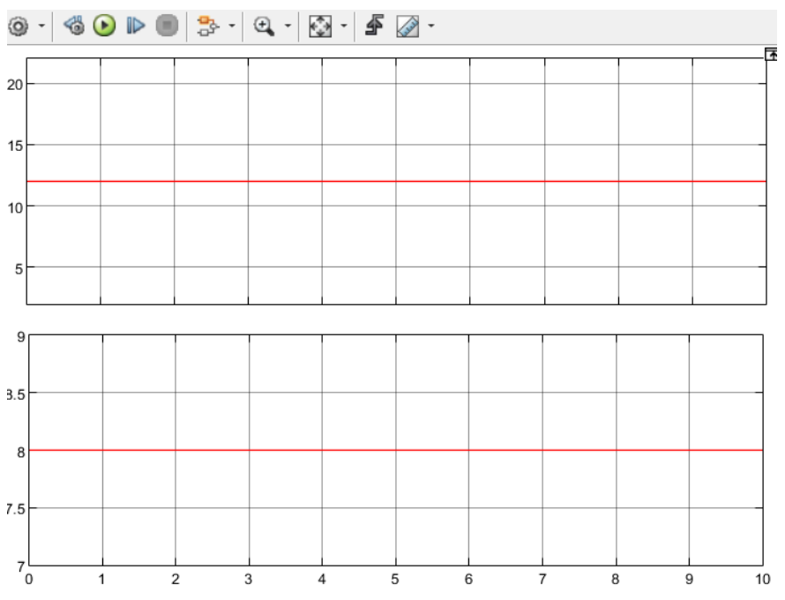
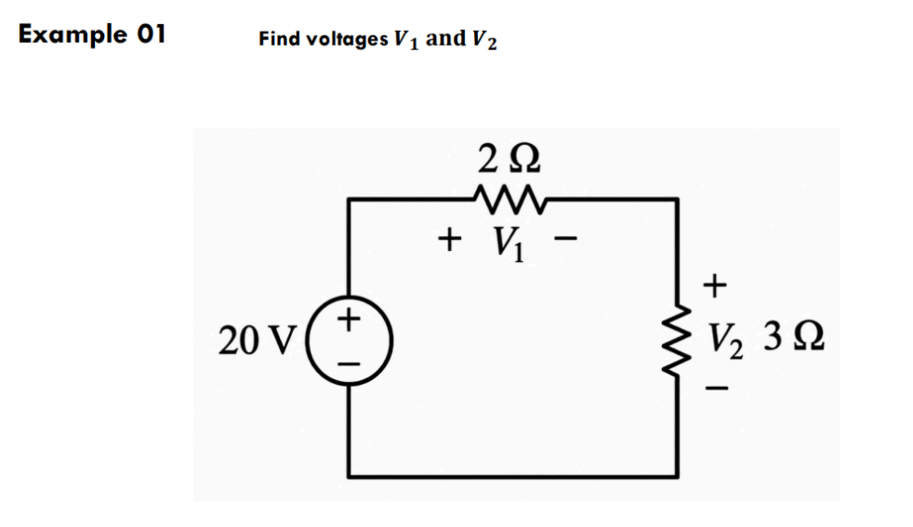
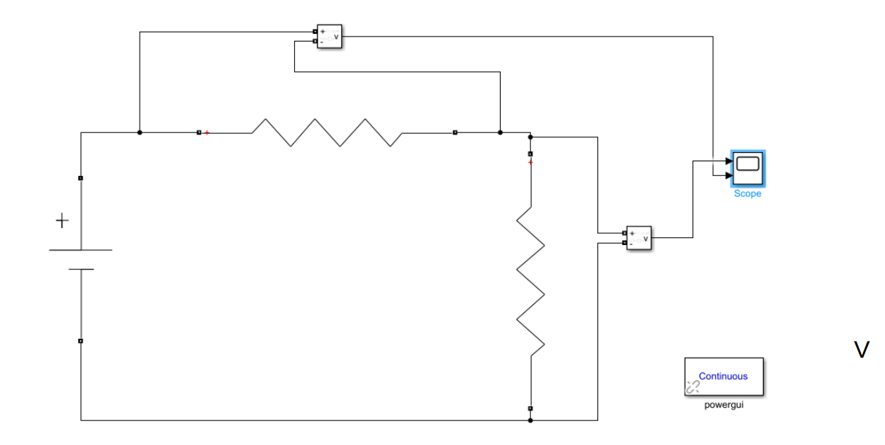
Example 02: DC Circuit with Current Sources
Calculate the node voltages in the given circuit using DC current sources.
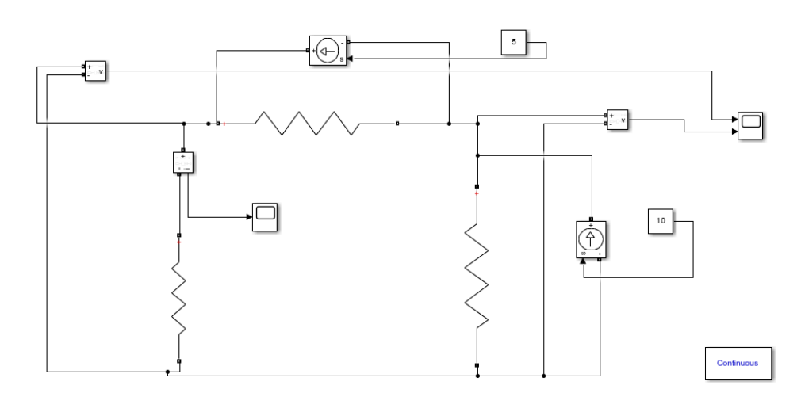
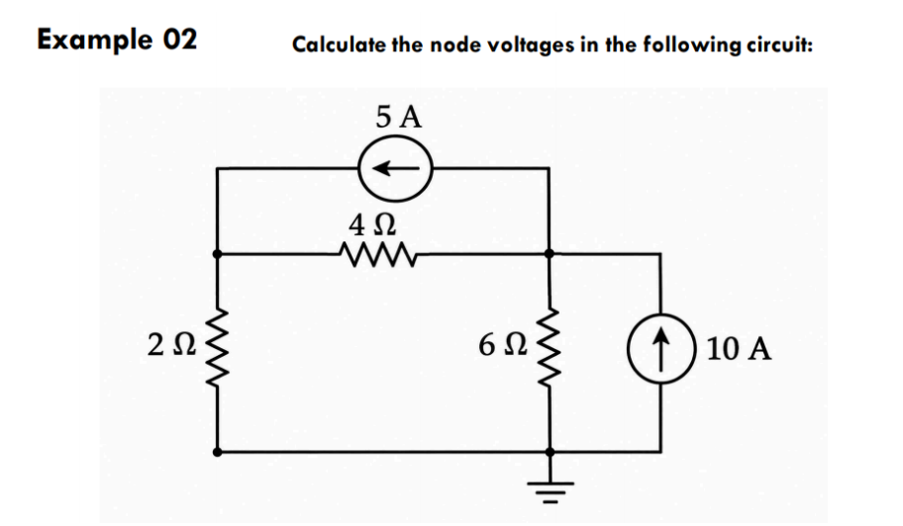

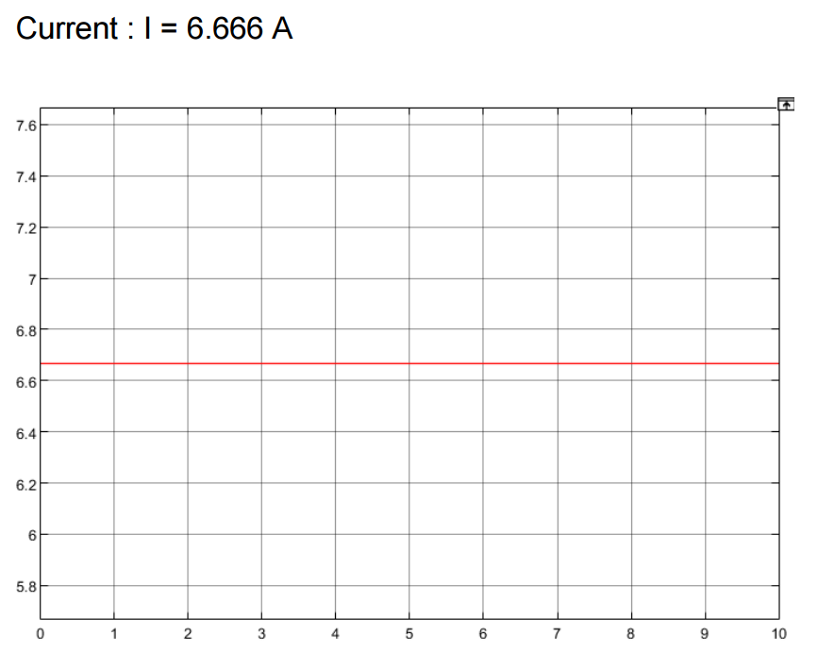
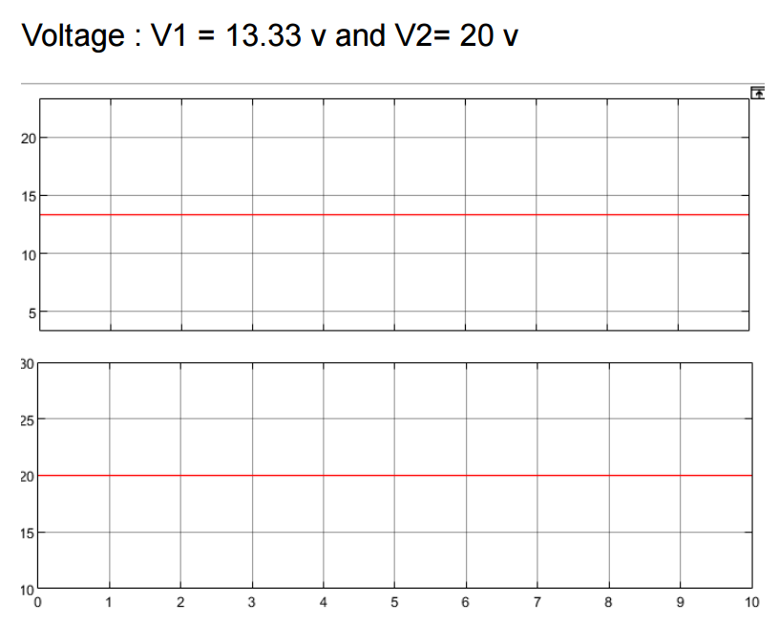
Example 03: Circuit with Dependent Source
Find the current i0 in the circuit featuring a dependent voltage source.
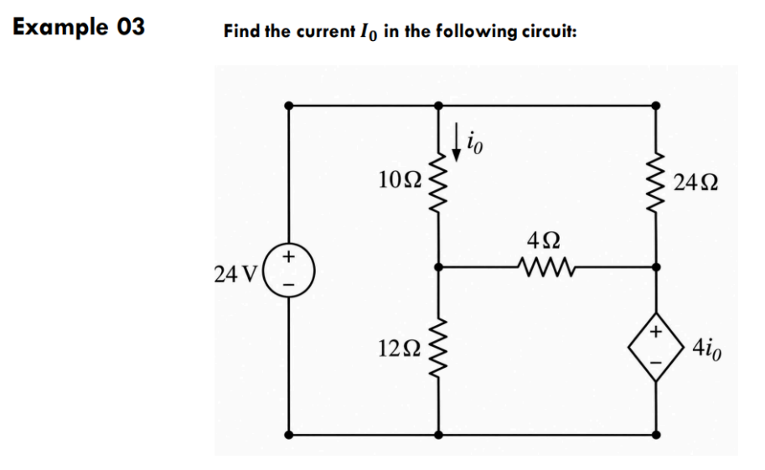
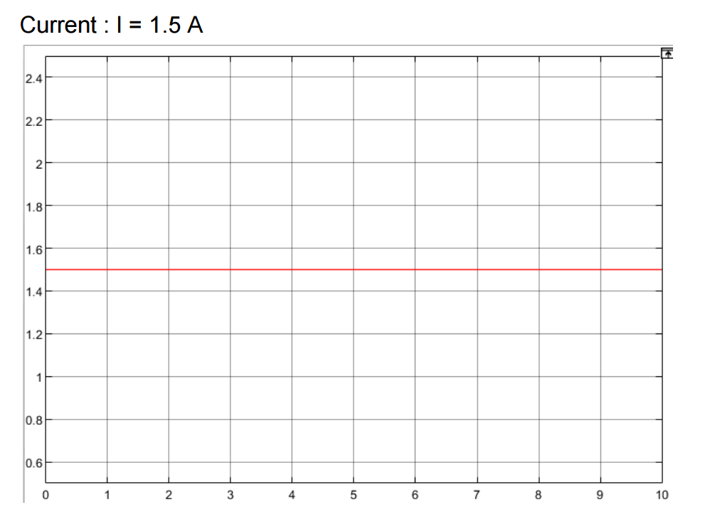

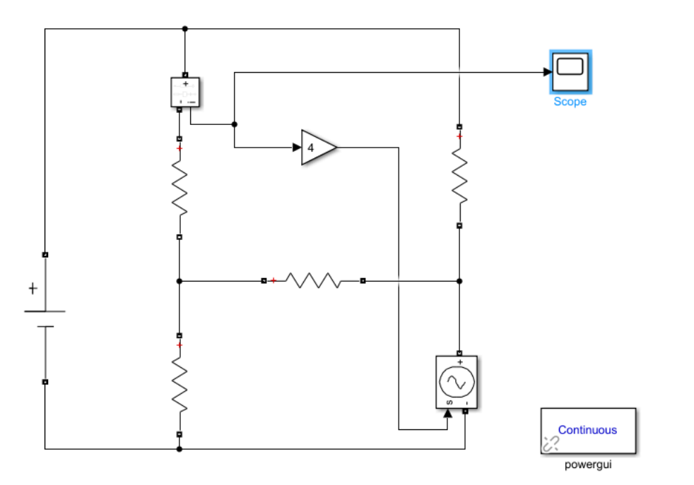

Example 04: Inverting Amplifier (Example 5.3)
Calculate the output voltage vo and the current in the 10-kΩ resistor for the inverting op-amp circuit.
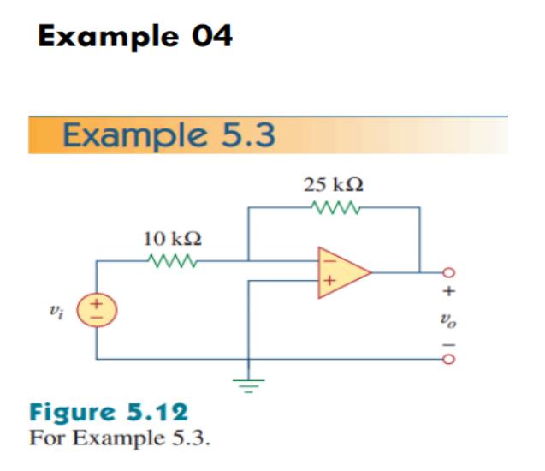
- Output Voltage is V = -1.25 V

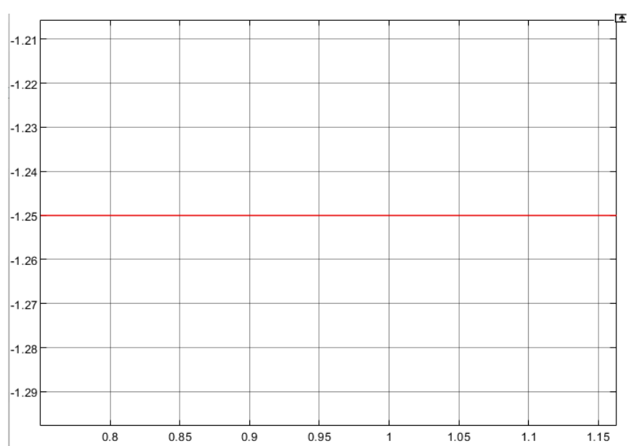
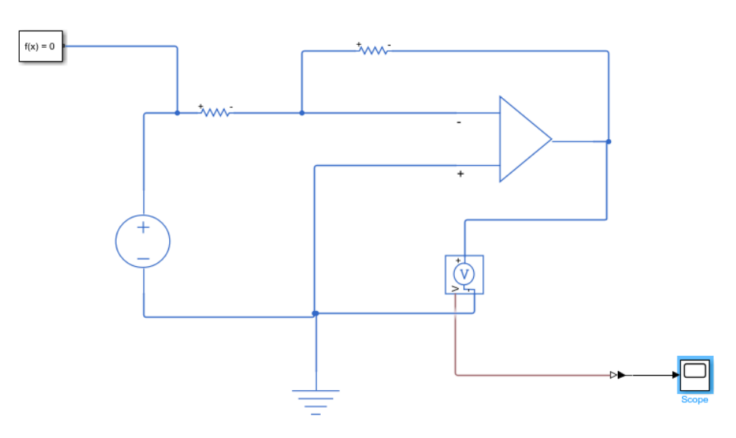
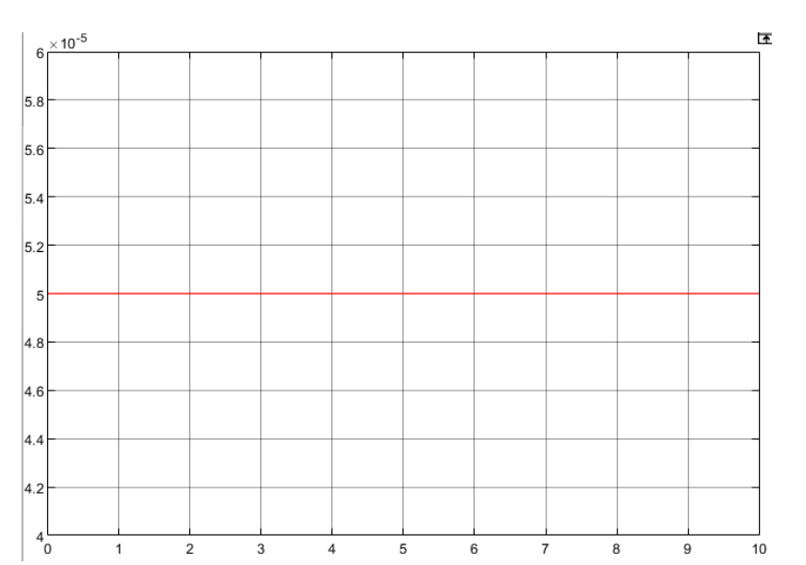
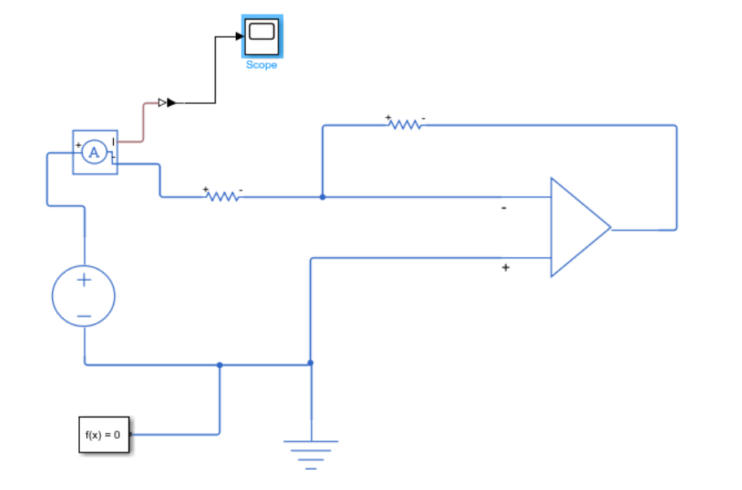
- Current through the 10K ohm is = 50 Micro Ampere

Example 05: Op-Amp Circuit Analysis (Example 5.5)
Calculate the output voltage vo for the given op-amp circuit with multiple DC sources.
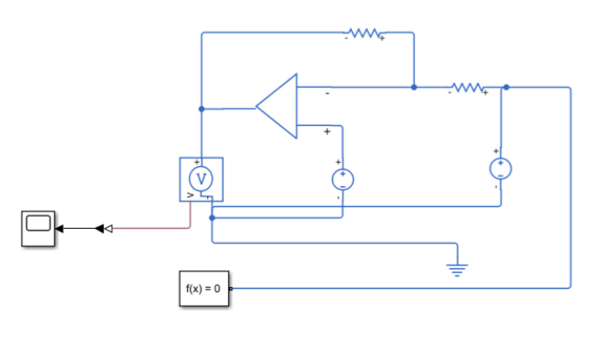
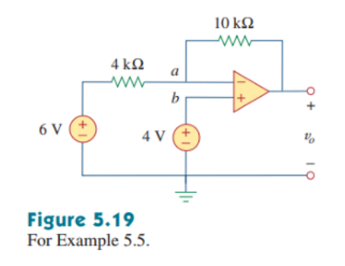
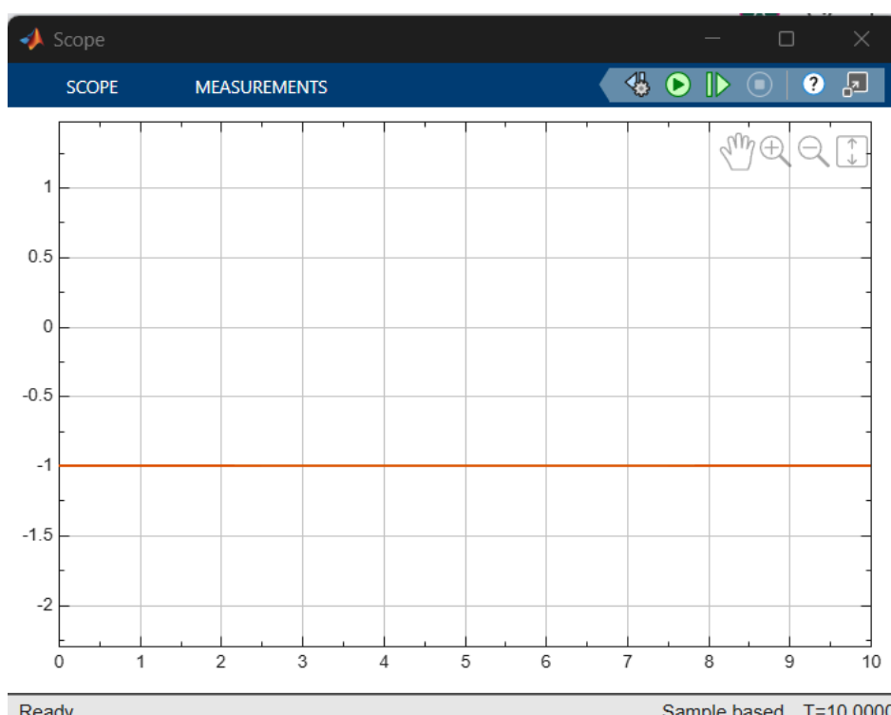

Example 06: Advanced Op-Amp Circuit (Example 5.6)
Calculate vo and io in the given op-amp circuit using Simulink-PS components.
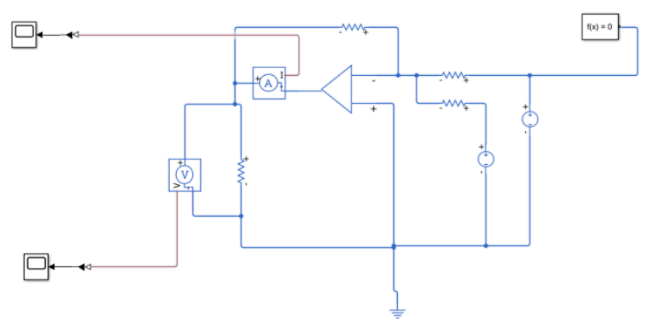
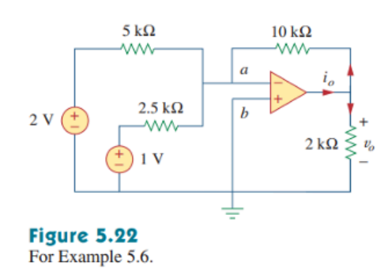

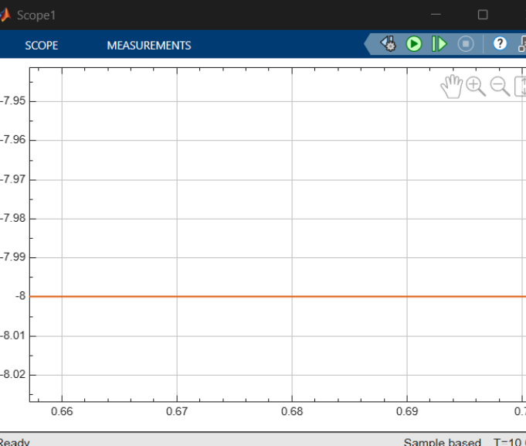
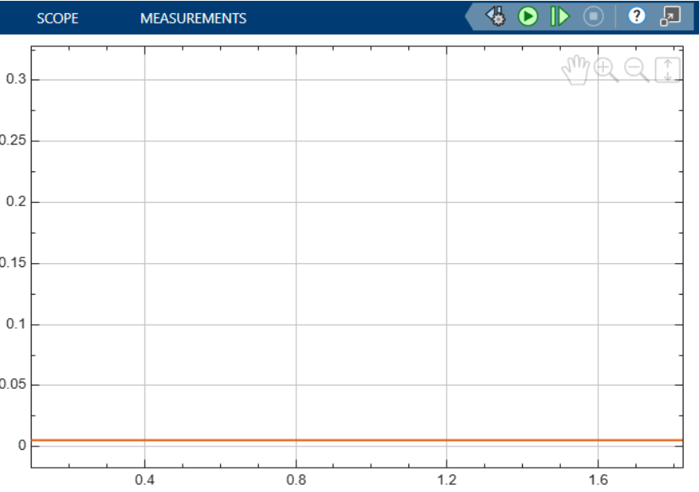
Example 07: Op-Amp Integrator with Capacitor
Sketch the output voltage for the circuit, given the triangular input voltage vi. Take vo = 0 at t = 0.


